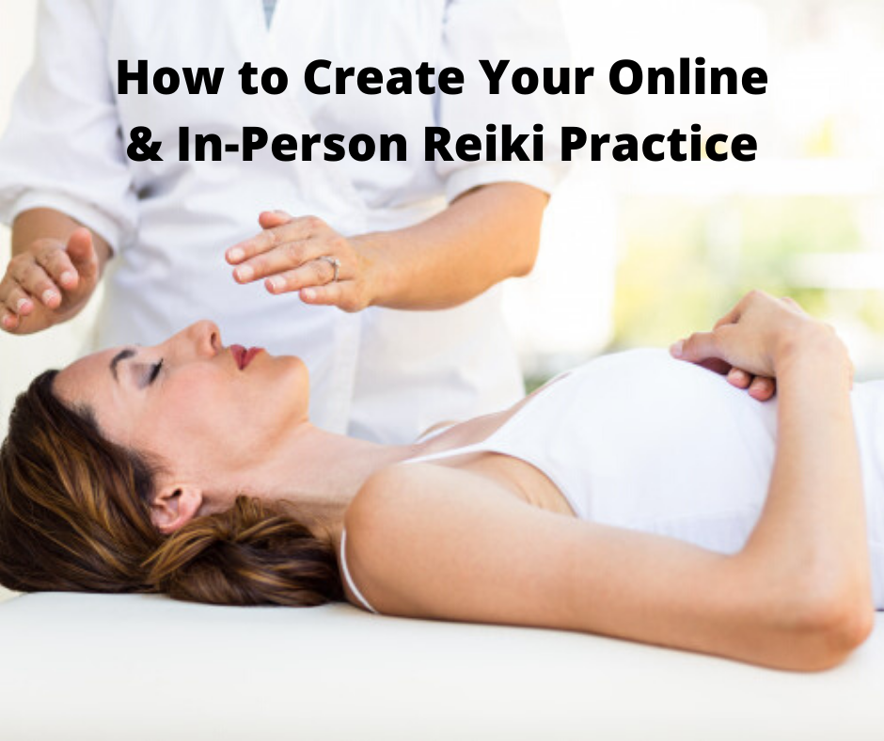

Index

The Essence of Reiki……………………………………………Page 3-3
Necessity to Obtain A Business License………………………...Page 3-4
Importance of A Business Website………………………………..Page 4-5
Necessities to Start A Reiki Business…………………………….Page 6-8
Necessities to Maintain Hygiene…………………………………...Page 8-9
In-Person Reiki Business…………………………………………….Page 9
Online Reiki Business………………………………………………Page 9-10
Distance Reiki………………………………………………………….Page 10

The Essence of Reiki

Reiki is an alternative therapy that deals with energy healing. It originated in Japan around the late 1800s. The process is said to involve the transfer of cosmic energy from the palms of the practitioner to their clients. The CERN European Organization for Nuclear Research conducted a study on Reiki and concluded with proof that life energy is emanated from the Master’s hand and transferred to the patient’s body in Reiki practice. There are many who view the market share for ‘modern medicine’ rather than admitting the effectiveness of Reiki. But the popularity of Reiki, thanks to its effectiveness, continues to grow. It is also known to treat a number of physical and emotional conditions. The word “Reiki” usually defines a miraculous sign or mysterious atmosphere. The translation of this Japanese word means universal life energy. Where there is physical injury or emotional pain, it becomes easier for energy to stagnate around these locations in the body. With time, these energy blocks are known to cause illness. Here are some of the common Reiki techniques:

- Beaming
- Clearing
- Centering
- Infusing
- Extracting harmful energy
- Smoothing and raking of the aura

The healing effects of Reiki are usually mediated by conveying the universal energy, also known as “chi” which is the life force energy surrounding all of us. Reiki supports relaxation, enforces the body’s natural healing process, and incorporates emotional, physical, mental, and spiritual well-being. Reiki has helped in treating conditions like chronic pain, heart disease, fatigue, autism, cancer, depression, infertility, and many more.

Setting up your own Reiki practice can enable you to assist people with their physical, spiritual, and emotional wellbeing as it promotes relaxation and healing so that they are able to live life to their fullest potential. Here are the following steps to go about it.

Necessity to Obtain A Business License

Almost all businesses require a combination of permits and licenses from both state and federal agencies. It is important for an enterprise to be licensed in order to operate legally. The fees and regulations vary depending on the location, government rules, and business activities. Luckily enough, getting hold of a legal business license is neither time-consuming nor expensive nowadays. Given below is the procedure to follow for obtaining a local business license:

- Understanding local requirements are necessary. This involves determining the area of conducting business and getting a license for that particular city.
- As different businesses have different codes, knowing the code for the kind of business that you want to run is crucial in order to get a license because each business code requires a different application process.
- Locate and fill the forms that serve the needs of your particular business type. Usually, the forms require information like the type of business, name of the business owner, business address, Federal ID number, contact information, and the number of employees.
- The filing of these forms with the respective city’s finance department is the first step toward obtaining the license.
- Depending on the requirement of the city and business type, the filing fee for the business licenses varies.
- Now that you have taken the necessary steps on your behalf, all you need is to wait for receiving the license. This could take a few days to a couple of weeks, depending on the business type.
- When the license finally arrives and you start operating, it is vital to follow the ordinances pertaining to your business and the rules drafted by the state or federal government for the business that is to be operated. Business licenses are usually subject to renewal from time to time.

Importance of A Business Website

It has become extensively easy to build a website without any prior knowledge in the field of web development, coding, and design. Whether for your personal use or professional use, creating a website hardly takes 1-2 hours with the help of proper tools. Here are some of the essential steps to follow to build a website:

- The very first step to creating a website is to choose a domain name. A domain is basically the website name and address. When a business website is in question, the domain name should reflect the name of your company to draw maximum traffic. A domain name usually costs USD $10-50 a year.
- Apart from a domain name, website hosting for your website is necessary. This is a service that stores all the content of a website on a secure server which is always up and running. Without a website hosting, the site will not be accessible for others to browse.
- Choosing a website hosting company that provides a domain name with SSL for security purposes, a one-click install for WordPress, custom email accounts, no traffic limitations, and a 24x7 customer support facility is important for the success of a website.
- On completing the domain name and web-hosting procedures, it is important to install a proper website building platform. WordPress is highly recommended as it is the most user-friendly platform that comes with several free templates, designs, and add-ons to give that essential professional touch to your website.
- Once WordPress is installed, you are required to test your domain address and verify the https settings for the website.
- It is now time to customize the website to keep up with the business motive. This will include choosing a theme and installing the same for the website, representing the idea of the business. In this case, it is important to keep in mind that the website showcases the purpose of Reiki. Hence, it needs to be aligned with the same.
- There has to be a proper trademarked logo that represents the brand. This needs to be added to the website for security purposes and brand recognition. Also, adjusting the website font and color scheme to match the necessities of Reiki is vital.
- Moving on, you should consider adding widgets and a sidebar to your website. However, the most important thing that needs to be on the website once it is up and running is the different content pages. Some of the necessary content pages for all websites irrespective of the business are Homepage, Contact page, About page, Service page, and an online shop or e-commerce page (if required). Also, set up a navigation menu to make it convenient for the audience to hop from one page to the other.
- Now, when the website is all ready to be launched, you can always add some extra information to make it more attractive and resourceful. This information should highlight the background of the business owner, some testimonials from customers, and necessary insight into the kind of services the audience would want to choose from.
- All in all, the website should reflect the idea of the business that will be conducted with some creativity and attractiveness for a successful turnover of the audience. It is important to remember that creating the website is the first step only. The site needs to be maintained and updated from time to time to ensure maximum traffic and a significant online presence.

Necessities to Start A Reiki Business

You have found the perfect business idea as a Reiki practitioner and have even set up a website for it. All the necessary steps to register your business either with the state or federal government may also be in place. But that is not enough to run the business successfully. Here are some key steps to follow and other necessities required to start a Reiki business:

- Business Plan - A business plan is essential for attaining success as an entrepreneur with respect to any business whatsoever. It helps in mapping out the specifics of the business such as the target market, the preliminary and ongoing costs, the name of the business, and the time required for your business to break even.
- Preliminary Costs - To save overhead expenses, many starts practicing Reiki at their home but if you want a Reiki center, research and costs are going to play a prime role. Selecting a convenient location is important for customer turnover. Apart from this, a Reiki business will require the following basics:

- A practice space that is well-decorated with soothing and warm colors and is also free from outside noise
- A Reiki table or a number of tables depending upon the requirement that ranges around $100-500
- A set of pillows, blankets, and linens that cost something around $100 per set
- Colored fabric for healing that costs around $5-10 per square yard
- A music player to set the ambiance
- A business management software to assist you in managing all business aspects - you can go for an outright software OR a hosted software on a monthly rental basis that costs $70-135 a month.
- A website, the most important tool to start your business.

- Recurring Costs - As your hand is your primary tool in practicing Reiki, the expenses in this business are minimal. However, there are some ongoing costs that cannot be overlooked such as the purchase and maintenance of equipment, laundering of linens and other essentials, insurance, advertising, and website maintenance costs.
- Practice Setup - Setting up your Reiki business will further require covering office contacts like phone and emails, client administration, policies involving fees, refunds, and cancellations, taxes, and client management.
- Client Management - This process involves steps to manage client information like client consent, client intake, client privacy, social media policies, and authorization for information release.
- Practitioner Charges - The fees usually depend on the practitioner’s experience and the duration of each session. As each session can last 45-90 minutes, the fees can be set anywhere in between $30 and $100.
- Marketing Strategies - Therapeutic services such as Reiki require the observance of ethical guidelines like refraining from deceptive advertising, crystal clear terms for Reiki service, refraining from creating unreasonable expectations, and prevention from overselling professional skills.
- Networking - Establishing a professional network related to Reiki skills paves the way for a number of benefits such as general education, professional advice and development, collaboration over projects, community service, and many more. Some of the professional networks you could consider connecting with are dieticians, doctors, occupational therapists, physiotherapists, pharmacists, social workers, child care centers, beauty salons, and weight loss centers.
- Promotions - Apart from word of mouth, there are several other methods to promote your Reiki business. Here are some of the ways:
- Sharing portfolios, online and offline, from testimonials of clients with whom you have been successful
- Hosting free talking sessions at the local community centers, health centers, or libraries
- Joining networking groups like the International Association of Reiki Professionals
- Making your website informative, utilizing social media, advertising in new age magazines, and keeping track of how people find out about your business to understand which marketing strategies work
- Review - A system of “review” can be of immense help to assess the different parts of the Reiki business once it is up and running. Here are some of the ways to review your business:

- Assess the parts of the business running successfully
- Assess the parts that need modifications
- Evaluate which part of the business is generating maximum income
- Consider all options available to cut down on expenses
- Assess different ways to expand the business
- In case of a website, identify how the performance of the online practice with respect to website traffic, social media followers, and newsletter subscribers

Necessities to Maintain Hygiene

These uncertain times can come up with unique challenges for spas and therapy centers. It is an absolute necessity to follow the hygiene protocols provided by your state or federal government while operating and conducting business from your respective centers. Sometimes even after maintaining the most extensive sanitation protocols such as client screening and social distancing precautions, there always remains a risk of COVID-19 transmission. Hence, here are some of the key hygiene practices to follow while conducting your Reiki business:

- Keep yourself updated with the latest guidelines set by the state in alignment with coronavirus safety measures, which are needed to have adhered irrespective of additional safety protocols
- Ensure that your professional liability insurance covers both your business and you for communicable diseases like COVID-19
- Facility cleanliness, disinfection, regular sanitization, and practitioner hygiene is highly recommended for all businesses likewise
- Thorough cleaning, sanitizing, and disinfecting protocols for the massage room or any other communal area or objects that have been touched by clients
- Regular laundry policy for all washable objects like linens, clothes, and towels
- Consider Personal Protection Equipment use like gloves, masks, and necessary protective clothing
- Since handwashing offers protection against COVID-19, it is important to take such hygiene protocols into account
- Keeping booking practices in mind, make necessary changes allowing sanitization and social distancing procedures to limit the number of people at the therapy center
- Evaluate cancellation policies in case a client shows symptoms of any illness
- Implement an advanced intake process considering pre-appointment communication minimizing all contact risks during check-in and check-out
- Online tools like MassageBook or ClinicSense helps in pre-appointment communication and streamline check-in and out
- Maintain considerable spacing between appointments so that there is enough time to clean in between and minimize interaction
- Put up signs and other necessities in waiting rooms emphasizing on handwashing, sanitizing, social distancing, and protective measures you expect your clients to use to help prevent the spread of COVID-19 virus

In-Person Reiki Business

Reiki is a practice that needs to be conducted in-person. So, it is important to keep in mind all the preventative measures and abide by them accordingly. This is essential because COVID-19 is a transmittable disease that can spread quite easily. Take all precautionary steps to avoid the spread of the disease by maintaining hygiene. Make sure to attend to all the legal steps required to protect the interest of your business. Decorate the practice area to act in accordance with your Reiki sessions. Most importantly, get hold of all the essentials such as Reiki tables, essential oils, fabrics, and other equipment necessary to conduct the business. Prepare guidelines for the center and for the business likewise. Always ask for permission from the client before proceeding with the session and follow client confidentiality. Perform each session thoroughly and ensure to follow up with clients. As word of mouth is a great way of advertisement apart from commercial means, you can ask your clients for feedback and also ask them to inform their friends and family about the sessions. When all of the mentioned procedures are followed, client upsurge becomes inevitable, and your business witnesses considerable growth and recognition.
Online Reiki Business

Reiki can be conducted online without even being online. There is always the option to set up/build a simple yet powerful website to promote your Reiki business and drop-in tutorial videos from time to time. Reiki classes can be performed online and, this is best supported by having a website as a foundation to garner clients and disseminate pertinent information. There are many website builder sites such as WIX, WordPress, SQUARESPACE, and so on. If this appears to be too daunting, you can opt for a company that offers virtual assistance such as MyTasker. Or, if money is no deterrent, you can hire a Web Designer.

A website will help in drawing in your target audience and bring your business into the limelight. You can always build a website by yourself or get it done with the help of a professional. Since building a website has become highly convenient nowadays, go through our booklet to build your own. A website boosts your online presence and keeps your clients and prospects informed about your Reiki business.

To run a successful Reiki business online, you are required to host more classes online. With the help of a computer and a stable Internet connection, it is very easy to conduct Reiki classes online. As Reiki can be performed from a distance, you have the liberty to meet your clients via online video conferencing platforms like Zoom or Google Meet. These tools are of immense help in carrying out all kinds of online businesses, especially during this pandemic. Taking online Reiki classes into account not only ensures preventative measures such as hygiene protocols and social distancing but also allows patients to receive care without having to risk in-person contact.
Distance Reiki

The structure and framework of our physical world functions in a way where most of our regular activities are required to be done in person. This can include anything from a simple haircut, a massage session, blood test, dental work, or manicure. None of these activities can be conducted from a distance. But Reiki stands apart in this case. With an advanced skill set and the client’s verbal or written consent, a professional Reiki practitioner can easily send out this life force energy or Prana and assist in healing the recipient. Reiki is non-intrusive and capable of holistically restoring the balance between the spirit, body, and mind. Reiki is known to promote the body’s regenerative self-healing abilities. Distance Reiki is only as powerful as the practitioner’s skill set. Reiki can be incredibly relaxing and Distance Reiki is best experienced when the client can lie down or relax. Distance Reiki will bring on relaxation and, at times, the relaxation is so strong that operation of driving a vehicle, operating dangerous equipment, or doing tasks that require concentration is wise to avoid. It is to be noted that all Distance Reiki classes are conducted online in my Reiki I and II classes during the COVID-19 Pandemic; and, the appointments may be made via the Integrated Energies LLC website.

Please visit the Integrated Energies Website at www.iellc4u.com for more details

Source links:

https://www.medicalnewstoday.com/articles/308772#health-benefits
https://www.wikihow.com/Obtain-a-Business-License
https://websitesetup.org/
https://howtostartanllc.com/business-ideas/reiki
https://www.reikitherapyresources.com/reiki-practice/
https://www.learnreiki.org/reiki-articles/starting-your-reiki-practice/
https://www.amtamassage.org/about/news/covid-19-resources-for-massage-therapists/

